GitHub
1 Create a GitHub account.
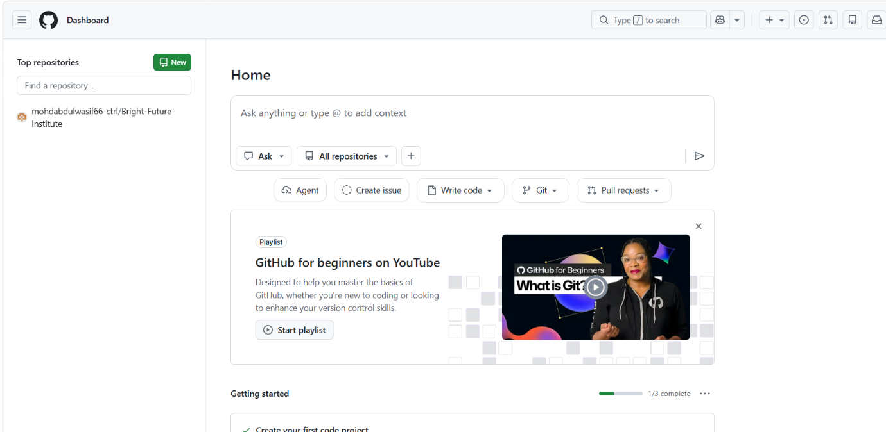

2. Set up MFA (Multi-Factor Authentication) for the GitHub account using a mobile app.
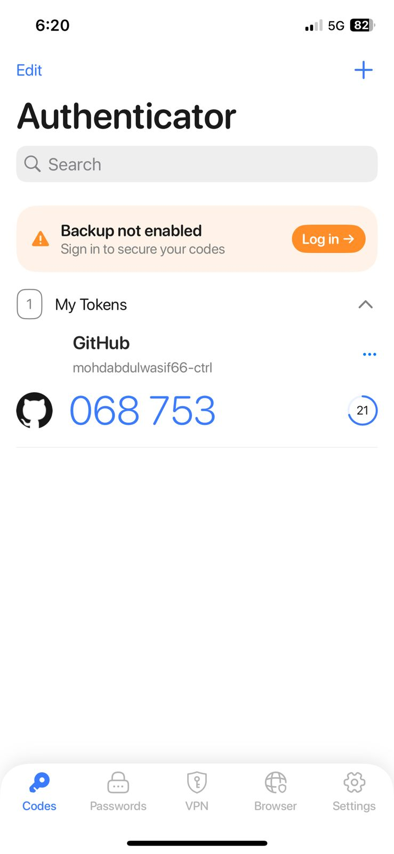
3 Execute all commands shown in the video.
installed git ( Sudo yum install git -y)
Started by ( git init)
checked status by ( git status)
checked version ( git - - version)
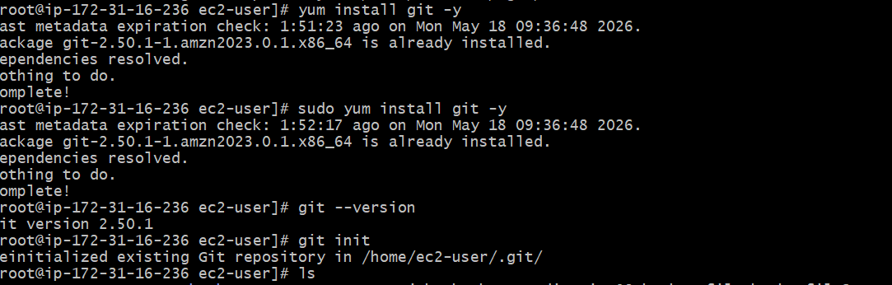
Then checked config( git config - - list)
Then added user name ( git config - - global user.name “ “)
Then user email ( git config - - global user.email “ “)
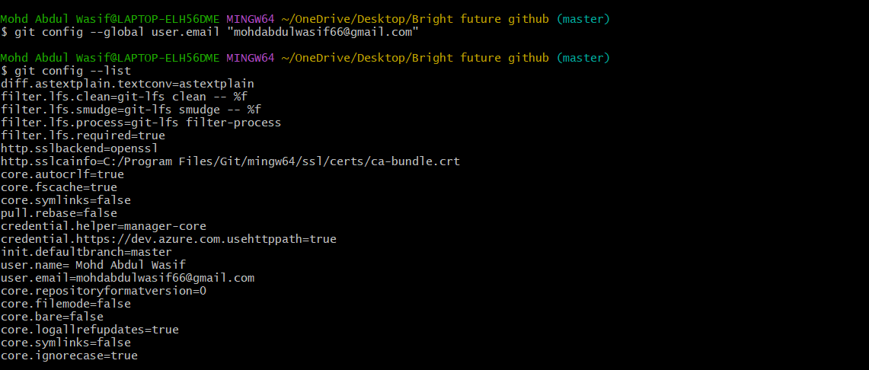

Then created file (touch command)
After that added both the file ( git add .)
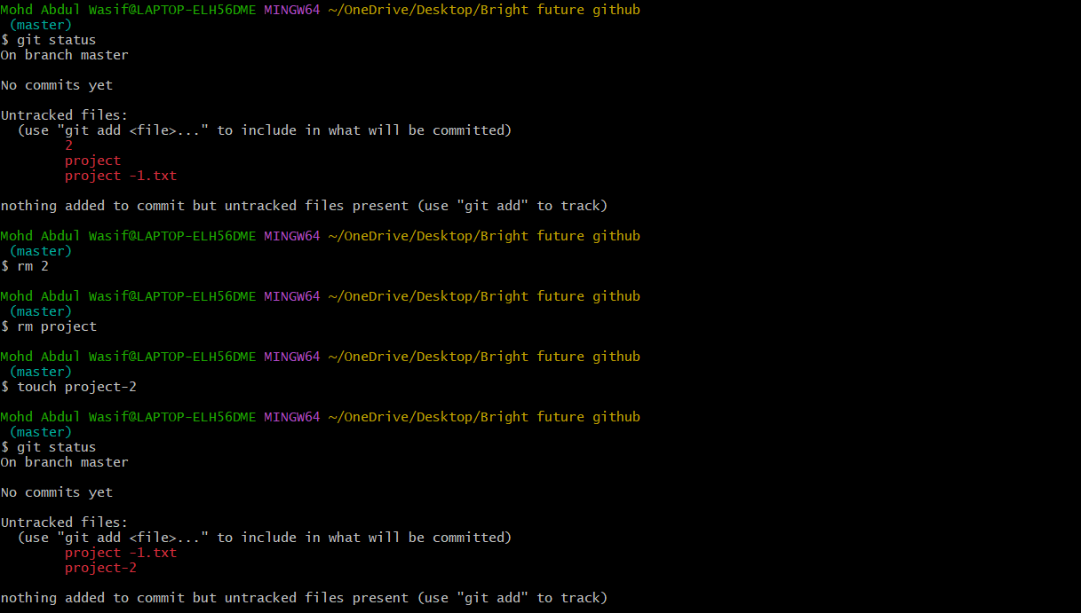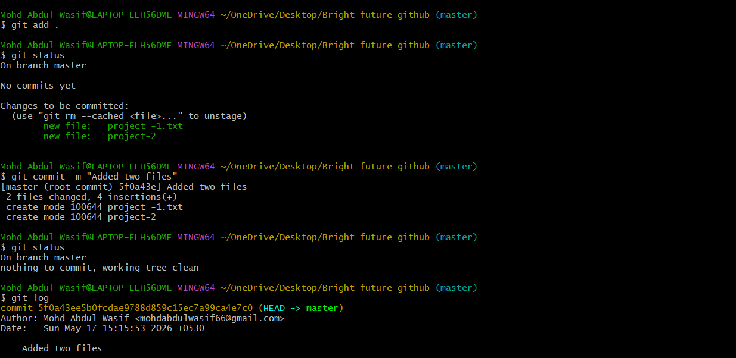
Then commit file ( git commit -m “ “)
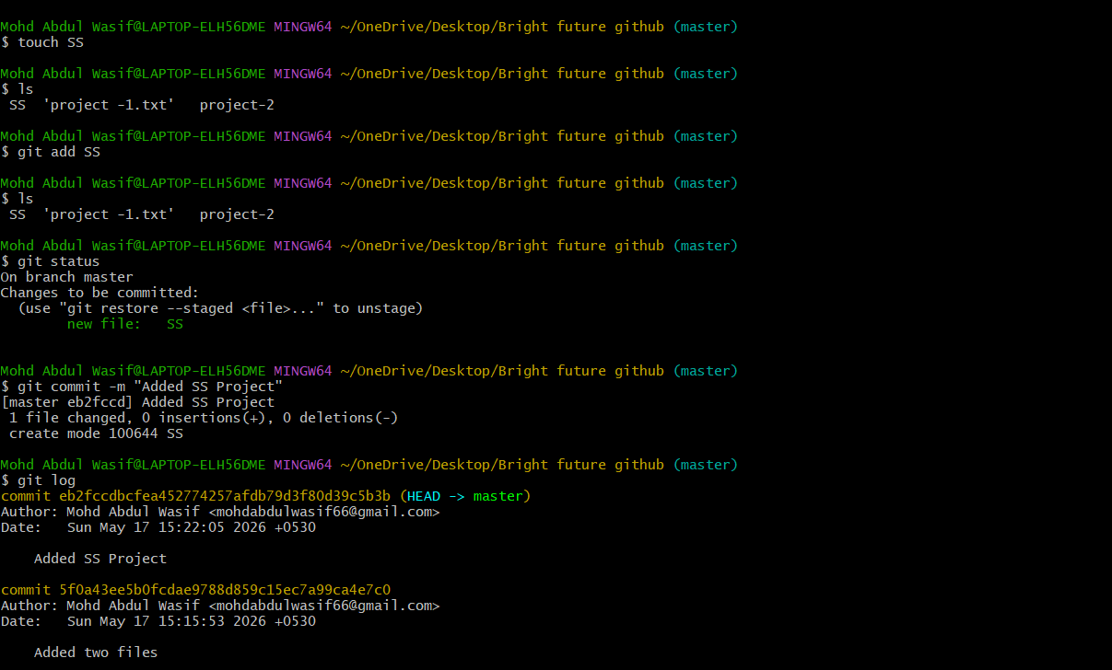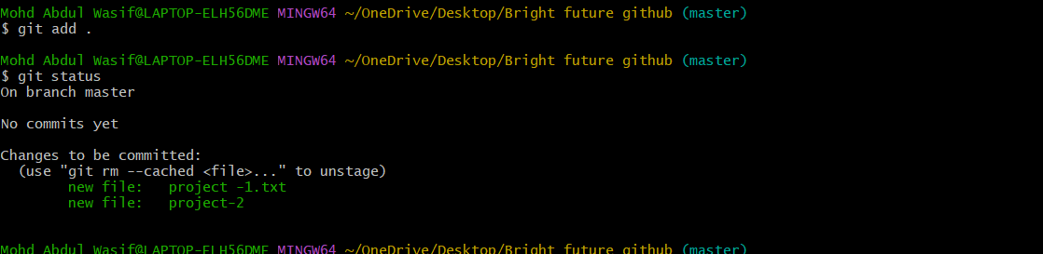
Then created Ssh ( ssh-keygen)
and login to github
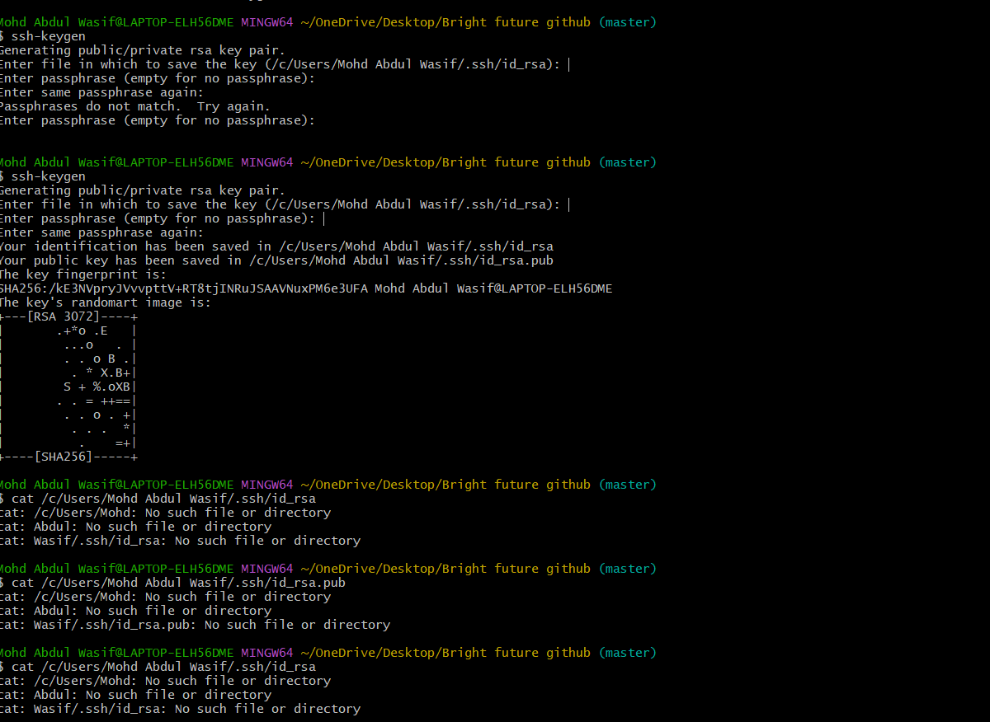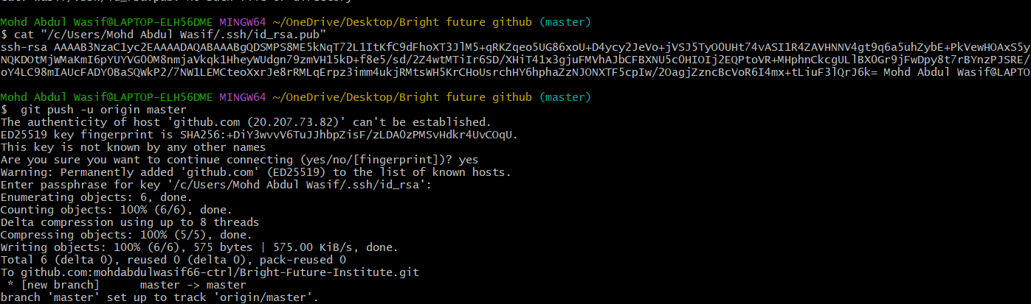
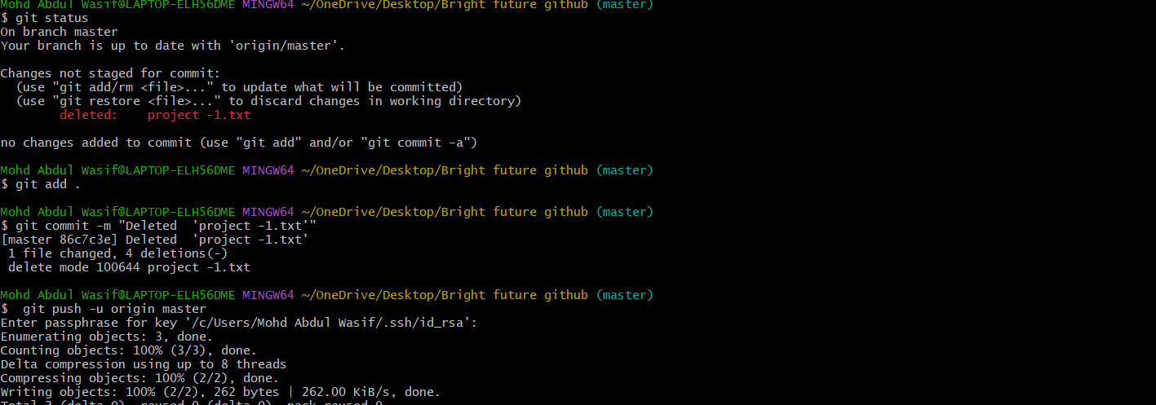
Then pull the files into the git hub (git pull -u origin master)
